**Initio Programming: Command Lines**



**AIM:** After completing this worksheet you should be able to use the Linux Command line to start up the Python interpreter and the Python command line to use simple print commands. You should also be able to stop the Python interpreter.

**You Need:** To complete this worksheet you need to have an Initio that is connected to a keyboard, mouse and monitor (see WS1).

The Initio robot is controlled using a Raspberry Pi computer that runs the Linux operating system. You will be doing most of your work at the *Linux command line*. To do this you need to open the Terminal application from the menu bar.

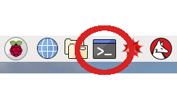

Raspberry Pi Menu bar, with the Terminal application circled

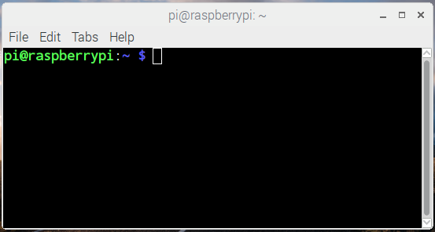

**A Terminal window**

If you are using an Elecrow 5 inch monitor then your terminal window will be slightly larger than the monitor. *Resize the window* using the mouse so that it fits into the screen space available.

For simple programming tasks we can use the *Python Command Line Interpreter*. We are going to use this from within an *integrated development environment* called IDLE. To start IDLE type idle3 at the Linux Command Line.

pi@raspberrypi:~ $ idle3

What happens when you do this?

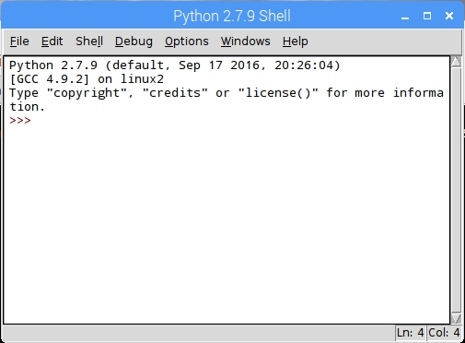





The Python Command Line Interpreter in IDLE

You should now be in the Python Interpreter which should look like the above. You DO NOT need to type the “prompt” (**>>>**) before any python commands.

**Step 1: Type**

**print(“Hello World”)**

Then press Return

What happens?

**Step 2: Type the following commands followed by Return**

**import robohat as initio**

**initio.init()**

**initio.forward(10)**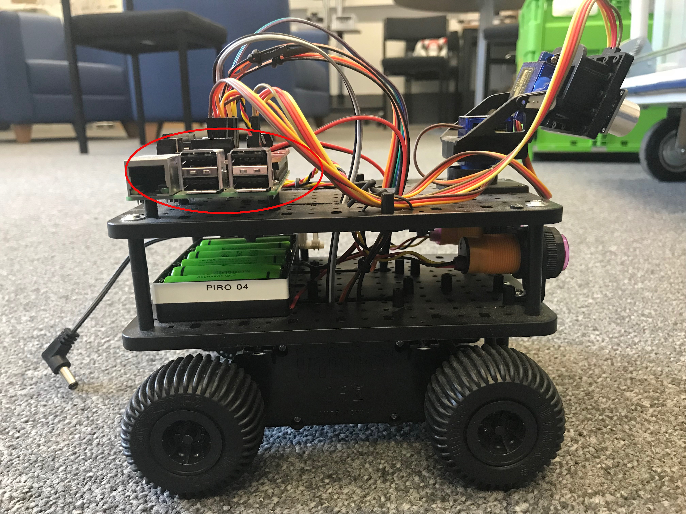

**initio.stop()**

What happens?

You can use *ctrl-p* (pressing control and p at the same time) to scroll back through previous commands.

**Step 3: Try replaying some commands using *ctrl-p***

You will learn more about controlling the Initio from the Python Command Line in worksheet WS3.

**IMPORTANT:** You can also start IDLE from the Raspberry Pi menu. However, if you do this it will not be able to control the Initio properly.

If you have finished working with your robot type:

**initio.cleanup()**

Otherwise carry on to worksheet 3.



University of Liverpool, 2019

This work is licensed under a [Creative Commons Attribution-NonCommercial-ShareAlike 4.0 International License](https://creativecommons.org/licenses/by-nc-sa/4.0/).